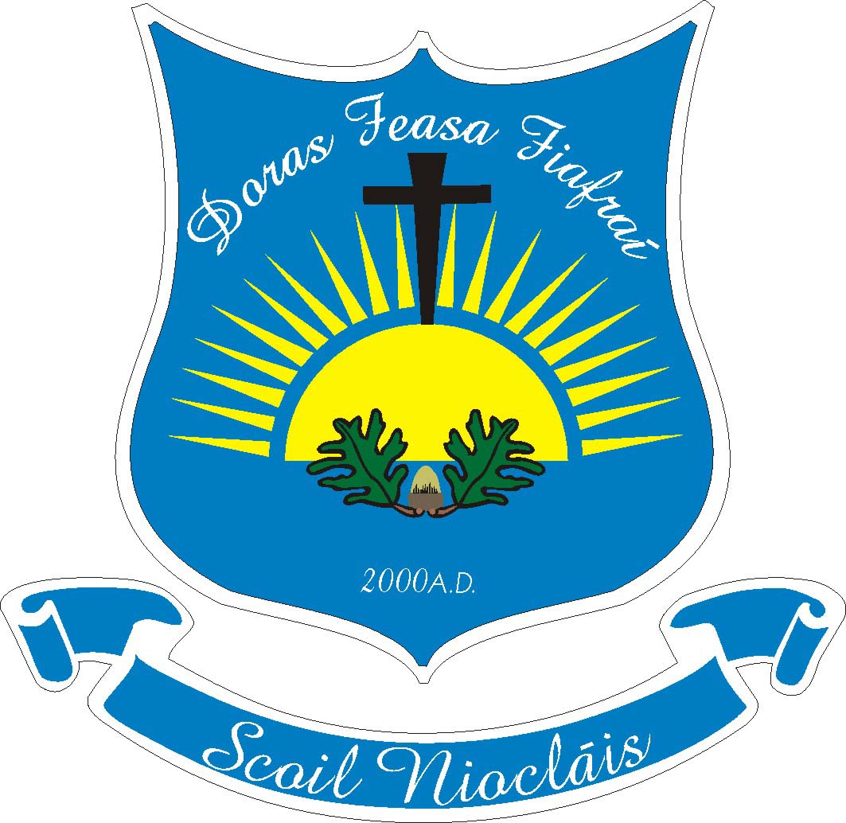
Scoil Niocláis,
Frankfield,
Grange,
Cork
Roll Number: 20106E
'Phone/Fax: 021 4899567
Mobile: 086 8270057
E-mail: scnioc@eircom.net
Website: www.scoilnioclais.ie

Príomh-Oide: Síle Uí Laoire B.Ed., Dip. Comp. Ed.
Príomh-Oide Tánaisteach: Rósmáire Ní Laoi B.Ed

School Uniform

The Scoil Niocláis uniform for our male students consists of a blue crested jumper, with a school tie and sky blue button down shirt, navy trousers, dark shoes.
Our female students wear a blue crested cardigan/jumper, the school tie and sky blue button down shirt with either;
- a tartan pinafore, navy socks or tights
or
- a navy trousers.
Leggings, tracksuit bottoms or white socks are not part of the school uniform. Black or navy shoes are worn by both girls and boys with the school uniform.
Children should not wear runners with the school uniform, only with the tracksuit.

On designated PE days or school trips students may wear the school tracksuit which consists of;
Sky blue polo shirt or the blue or white school jersey.
Navy and sky blue crested tracksuit top and navy school tracksuit bottoms with sky blue trim
School shorts may be worn from May 1st to October 1st each year.
Junior and Senior Infant boys and girls wear the school track suit as their uniform daily.
Uniforms and Tracksuits are available from Laura’s Douglas and Cahill’s Carrigaline and Oliver Plunkett Street

Reviewed by the Board of Management of Scoil Niocláis on _____________
Signed on behalf of the Board

_____________________ ___________________
Chairperson Date

______________________ ___________________
Principal Date

